STUDENT EMPOWERMENT

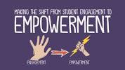

Our motto is to empower students with learning differences by helping them understand their strengths and weaknesses, giving them the tools they need to succeed and become strong self-advocates.
Our Vidyalaya is totally committed for student empowerment. Throughout the session numerous activities are conducted to bring an all-round development in our students to make them constructive and self-dependent citizens. The activities which our vidyalaya takes up for student empowerment are:
- CCA activities- Drama, Debate, Elocution, skit, speech for development of communication skill
- Sports activities- Inter-House, Inter- School, Regional and National sport meets for physical and social development
- Science exhibition – To develop Scientific temper
- Ek Bharat Shreshta Bharat Programme ( Social Science Exhibition)
- SUPW activities for skill development
- Computer literacy programme
- Scouts ant Guides Programme
- AEP for developing life skills
- Counselling sessions for career selection
- Provision of Remedial and Extra classes for Academic excellence
Effective Communication trains students in impactful communication skills and effective expression of views.
Study Smart modules provide strategies for improving student learning levels and in making student-directed learners.
The modules improve students' self-confidence and self-image. They help students to articulate their personal strengths and weaknesses.
Ability to handle peer pressure helps students to resolve conflicts assertively, and promotes greater collaboration among peers.
The diverse imaginations, observations, opinions, hopes, and dreams of students are the most powerful resource. The changing global scenario requires children to be successful not just academically but also with dealing with life challenges. They need to be equipped with skills to negotiate these challenges. The Student Empowerment helps students to acquire skills to improve communication, confidence, motivation levels, and interpersonal relationships to reach their greatest potential. The students discover life skills that help them blossom into secure and confident young adults.
The workshops under the students' program are highly interactive to satisfy the needs of today's students. The activities include role playing, debates, presentations, brainstorming, demonstrations etc.
The program is highly interactive; it provides real-life situations for students to build their skills in creativity, innovation, critical thinking, problem solving, and decision-making. It grooms the students and prepares them to be leaders.

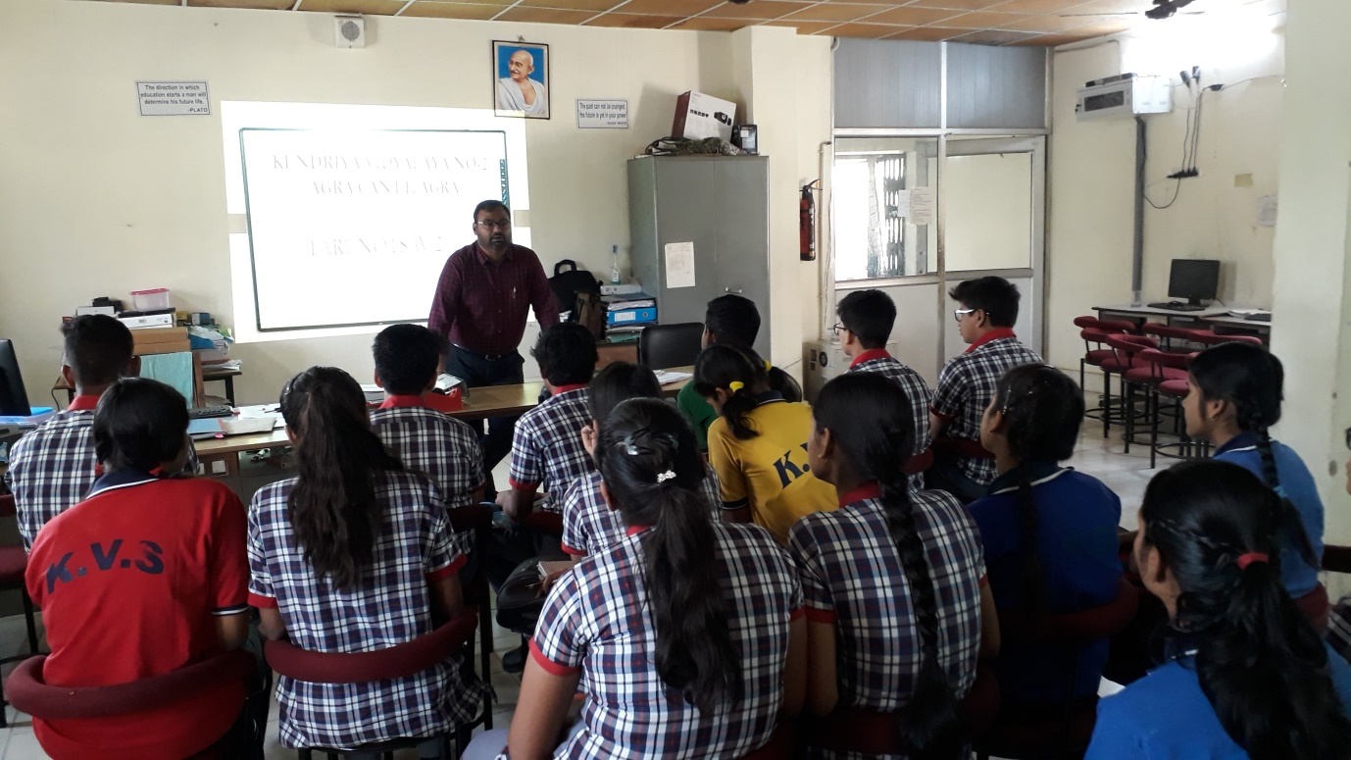
COUNSELLING OF STUDENT BY VIDYALAYA COUNSELLER

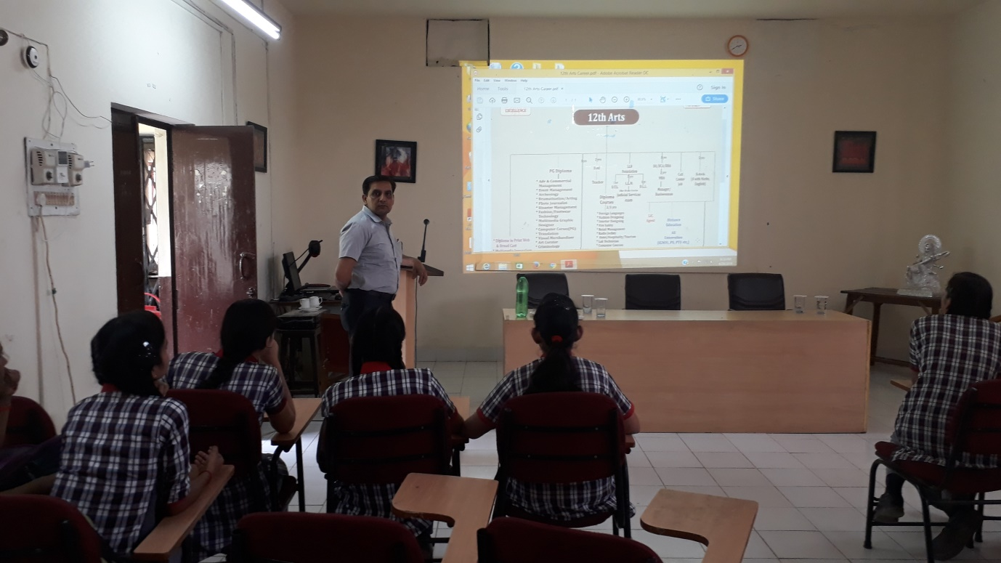
SESSION ON CAREER OPTIONS FOR CLASS XI STUDENTS

