SOP/ NDMA
SCHOOL SAFETY
School safety has been defined as the creation of safe environments for children starting from their homes to their schools and back. This includes safety from natural hazards of geological/climatic origin, human made risks, transportation and other related emergencies
PREPAREDNESS AND RESPONSE AT THE LOCAL LEVEL
- School has nominated safety focal point teacher.
- School has sensitized the school management committee.
- School has developed a cadre of peer educators.

SCHOOL DISASTER MANAGEMENT PLAN HAS
- Systems of warning ( centralised PA system)
- Identification of evacuation routes
- Access by emergency vehicles
- Care of children with special needs
- Stockpiling of emergency equipment and regular maintenance
- Arrangement for orderly release of students during emergency
- Site map indicating evacuation routes and assembly areas

SOP FOR DEALING WITH TERRORIST ATTACKS

PREVENTIVE MEASURES TAKEN BY VIDYALAYA
1. Boundary wall around Vidyalaya building
2. Emergency numbers displayed
3. Telephone at the gate
4. Illumination around boundary
5. CCTV Camers

6. Centralised PA system
7. Alarm system
8. Concertina wire along boundary wall

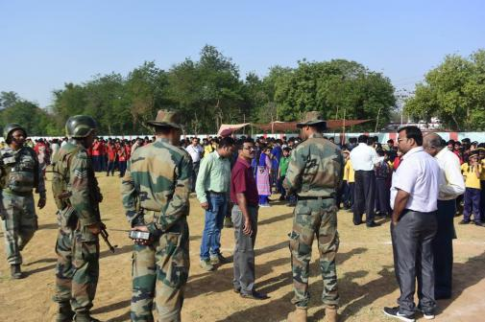
Disaster Management Drill

