GENDER SENSITIZTION
Gender Sensitization
Gender Sensitization refers to the modification of behaviour by raising awareness of gender equality concerns. This can be achieved by conducting various sensitization campaigns, workshops, programmes etc. sensitization in the domain of "humanities and social sciences, is seen as “the awareness about informed disposition or propensity to behave in a manner which is sensitive to gender justice and equality issues.
The Indian Society is still in the process of modernization where sections of the population continue to have traditional mind-sets. The traditional Indian thinking considers males as superior to females.
Our Vidyalaya is totally committed for gender equality and conduct various activities through AEP club to sensitize students for gender equality. Students are regularly made aware about:
- POCSO Act
- Good touch and Bad Touch
- Growth and Development in Adolescents
- Peer pressure
- To have respect each other’s space
- Gender stereotype
- Interpersonal relationship
Sessions by Counsellors and Doctors are also organised from time to time to sensitize students for gender equality. Vidyalaya has also placed a question box where students can put their queries anonymously without hesitation. The queries are discussed and answered by trained teachers and counsellors during sessions.

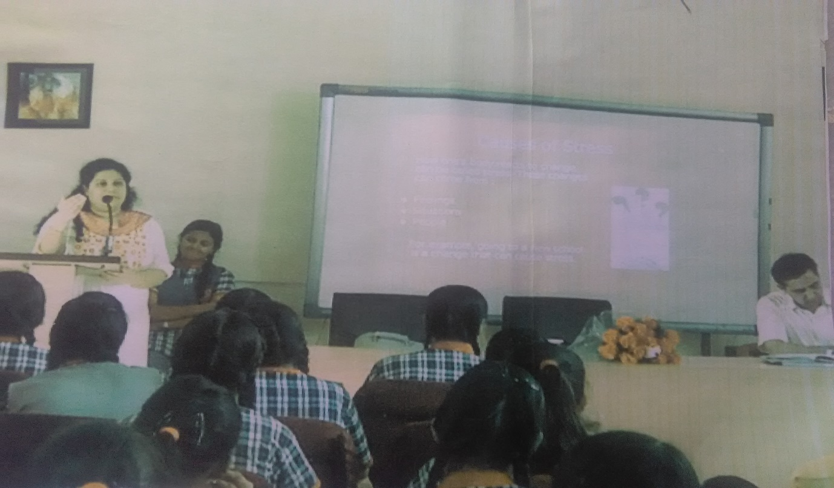
SESSION BY COUNSELLOR FOR SENIOR GIRLS
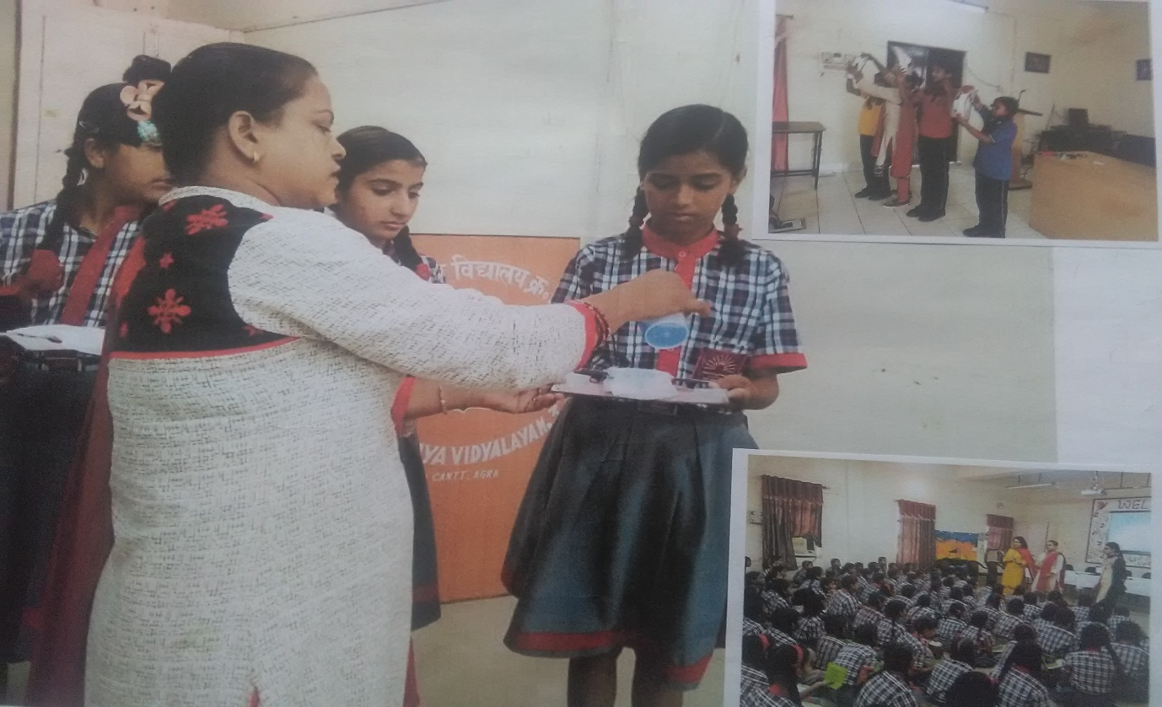
SESSION BY DOCTOR FOR JUNIOR GIRLS

